

Marine Corps veteran from Toledo part of flotilla trying to deliver humanitarian aid to Gaza

TOM HENRY
The Blade
thenry@theblade.com

Sep 12, 2025

A Toledo man is part of a large flotilla trying to get humanitarian aid delivered to victims of the war in Gaza.
Phillip Tottenham, 47, a Marine Corps veteran and member of the nonviolent activist group Veterans For Peace, called Friday from a 46-foot sailboat docked in Tunisia.
The boat he is on, called Ohwayla, is part of a 22-boat flotilla that hopes to get past Israel’s blockade of Gaza to deliver food and other aid in the coming days.
The boats are part of what’s called the Global Sumud Flotilla, or GSF, which is described on a website as the largest civilian maritime mission organized to break Israel's siege on Gaza.
He said Ohwayla’s passengers are mostly U.S. veterans, many of them fellow members of Veterans For Peace.
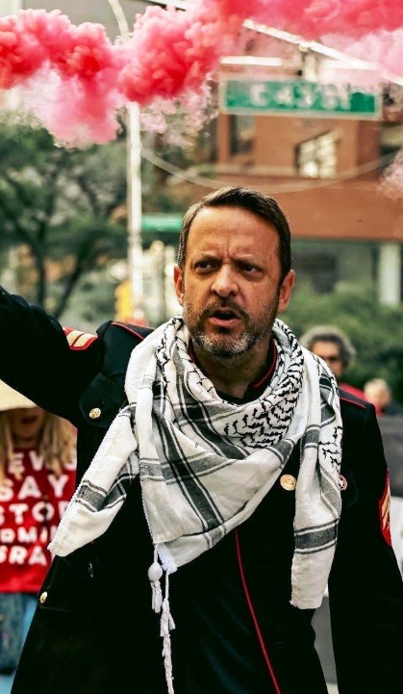
The flotilla has people from 44 countries. It started in Barcelona on Aug. 31 and is expected to be joined by other boats from Sicily and Greece soon, Mr. Tottenham said.
The GSF website states that it is a massive campaign with a nonviolent mission that has been coordinated by grassroots organizers, seafarers, doctors, artists, and activists who have empathy for Palestinians.
“We’re going to set sail in the next couple of days and make our way to Gaza,” said Mr. Tottenham, who moved to Toledo from San Antonio about a year ago.
He and other activists have been told they are subject to being incarcerated inside Israeli prisons designated for terrorists but won’t let that deter them.
Phil Tottenham protesting at Israeli Mission to U.N. July1, 2025
Photo Alexa Wilkinson

Trending Articles
“We’re putting our lives and safety on the line because humanity is on the line,” Mr. Tottenham said. “We’re trying to break the blockade and make it to Gaza, [then] deliver humanitarian food and aid [from the boats] and establish a humanitarian corridor.”
He said he’s over in that part of the world because “now’s the time to fight for humanity.”
Mike Ferner, a former Toledo city councilman, two-time Toledo mayoral candidate, and founder of the environmental group Lake Erie Advocates, has twice served as Veterans For Peace’s interim executive director.
He and Mr. Tottenham were part of a 40-day fast in protest of America’s support for Israel that ended in New York City on June 30.
Mr. Ferner had to leave early because of health issues but returned for the final day of the protest to throw a can of cow’s blood on the side of the U.S. Mission to the U.N. building.
He said at the time he did that to protest U.S. involvement. Mr. Ferner was charged with criminal tampering, unlawfully possessing or selling of a noxious material, and disorderly conduct.
“Phil's courage is surpassed only by his compassion,” Mr. Ferner said. “As veterans, we know what war does and the U.S.-Israeli genocide in Gaza has brought that ex-Marine to tears. Fortunately, he has retained the good part of his Christian upbringing and is convinced the power of love will overcome the love of power. I saw him live that belief every day we were on the Veterans & Allies Fast for Gaza at the U.N. this summer.”
Mr. Tottenham said he’s had empathy for Palestinians since the 2014 conflict in Gaza, in which the United Nations reports that 2,251 Palestinians were killed and 11,231 were injured over 50 days. The agency reports that 1,462 of the Palestinians who died were believed to have been civilians.
Sixty-six Israeli soldiers and five Israeli civilians also were killed, the United Nations states on its website.
Stephen Rothschild, CEO of the Jewish Federation and Foundation of Greater Toledo, said the flotilla “will not help the problem.”
“The situation in Gaza is tragic,” Mr. Rothschild said. “The situation could have resolved nearly two years ago if Hamas had released the hostages. It refuses to lay down its arms and release the hostages. We wish the situation was different, and this flotilla will not help the problem.”
The government of Israel has repeatedly denied accusations of genocide.

